Project: Moffat Bay Lodge
Course: CSD 460
Andres Melendez
Jeffery Reid
Jordany Gonzalez
Edgar Arroyo
Matthew Trinh
Description: Creating test cases for the Moffat Bay Lodge’s Landing Page, Login Page, and Registration Page
Date: 2025/04/19
To complete the test case plan, fill out the information for Project, Course, Description and Date in the header below.

TABLE OF CONTENTS
Landing Page 1:Verifying Landing page Loads Successfully 2
Landing Page 2: Test Navigation from landing page 3
Login Page 1: Incorrect login> 4
Login Page 2: Successful Login 4
User Registration 1:Successful User Registration 5
User Registration 2: Registration with Missing Required Field 5

Test 1 | Landing Page 1:Verifying Landing page Loads Successfully
 | Test Objective: Ensure that the landing page loads correctly and displays all essential elements. | Developer: Andres Melendez  Date tested: 2025/04/11 | Peer tester: Edgar Arroyo  Date tested: 2025/04/11
Step | Action | Expected results: | Developer pass/fail | Tester pass/fail  + Screenshot
1 | Navigate to Landing page | Landing page exists | pass | Pass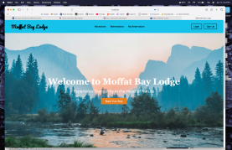
2 | Landing page Loads | The landing page loads within 5 seconds | pass | Pass
3 | Check key elements | Navigation bar, main heading, call-to-action, footer are visible | pass | Pass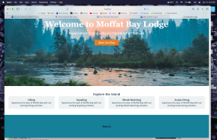
4 | Click on “Book Now” or main CTA button | Button scrolls to reservation section or redirects appropriately | fail | Fail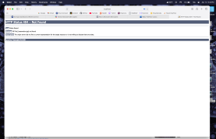
Comments | Comments should be substantive; this means there should be at least 2-3 well-structured sentences with constructive feedback.

Test 2 | Landing Page 2: Test Navigation from Landing page
 | Test Objective: Verify that navigation links on the landing page redirect users to the correct pages. | Developer: Andres Melendez  Date tested: 2025/04/11 | Peer tester: Edgar Arroyo  Date tested: 2025/04/11
Step | Action | Expected results: | Developer pass/fail | Tester pass/fail  + Screenshot
1 | Locate the navigation menu | Navigation menu appears at top of the page | pass | Pass
2 | Click on each link one at a time | Each link directs to its intended page without error | fail | Fail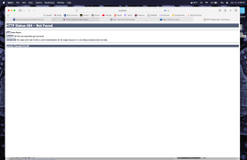
3 | Click on “Login” | Redirects to the login page with username/password form visible | pass | Pass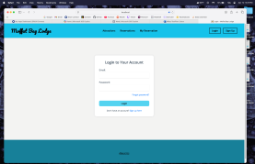
4 | Click on “Sign” | Redirects to the registration form with input fields visible | pass | Pass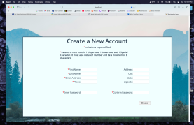
5 | Click on “Reservations” | Redirects to the reservations booking section or dedicated page | fail | Fail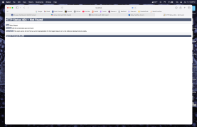
6 | Click on “Attractions” | Loads attractions page listing nearby places or activities | fail | Fail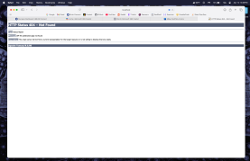
7 | Click on “My Reservations” | Redirects to user's reservation list (requires login) | fail | Fail
Comments | Comments should be substantive; this means there should be at least 2-3 well-structured sentences with constructive feedback.

Test 3 | Login Page 1: Incorrect login>
 | Test Objective: Validate that incorrect login information shows an appropriate error message | Developer: Jordany Gonzalez  Date tested: 2025/04/12 | Peer tester: Edgar Arroyo  Date tested: 2025/04/12
Step | Action | Expected results: | Developer pass/fail | Tester pass/fail  + Screenshot
1 | Navigate to login page | Sees the login portal | Pass | Pass 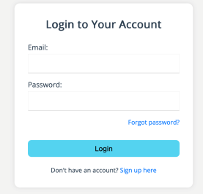
2 | Enter wrong username and password | To be able to press login | Pass | Pass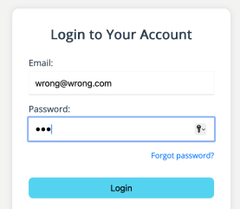
3 | Click login | Login fails  sees an invalid username/password error message | Pass | Pass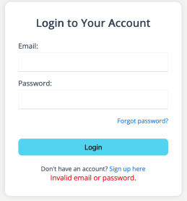
Comments | Comments should be substantive; this means there should be at least 2-3 well-structured sentences with constructive feedback.

Test 4 | Login Page 2: Successful Login
 | Test Objective: Ensure that a user can successfully login with valid username and password  Assuming: Account has already been created | Developer: Jordany Gonzalez  Date tested: 2025/04/12 | Peer tester: Edgar Arroyo  Date tested: 2025/04/12
Step | Action | Expected results: | Developer pass/fail | Tester pass/fail
1 | Navigate to Login page | Sees the login portal | Pass | Pass  
2 | Enter valid Username and Password | To be able to press the Login button | Pass | Pass  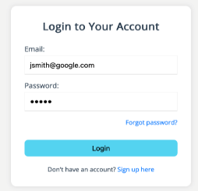
3 | Click Login | User is logged in and redirected to a dashboard | Pass | Pass  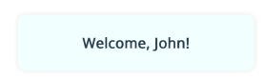
Comments | Comments should be substantive; this means there should be at least 2-3 well-structured sentences with constructive feedback.

Test 5 | User Registration 1:Successful User Registration
 | Test Objective: Ensure that a new user can register successfully with all valid information | Developer: Jeffrey Reid  Date tested: <2025/04/13> | Peer tester: Edgar Arroyo  Date tested: 2025/04/12
Step | Action | Expected results: | Developer pass/fail | Tester pass/fail
1 | Navigate to registration page | To view registration form with required fields | Pass | Pass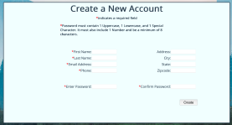
2 | Enter valid data in all required fields  Full Name: Joe Smith  Email: joesmith@example.com  Password: StrongPass123!  Confirm pass: StrongPass123! | Input all valid data | Pass | Pass 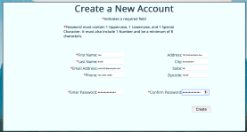
3 | Click register button | Registration is successful  Leads to a user dashboard | Pass | Pass 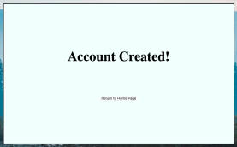
Comments | Button to submit registration form is “Create” not “Register”.

Test 6 | User Registration 2: Registration with Missing Required Field
 | Test Objective: Verify the system prevents registration when required fields are missing. | Developer: Jeffrey Reid  Date tested: <2025/04/13> | Peer tester: Edgar Arroyo  Date tested: 2025/04/12
Step | Action | Expected results: | Developer pass/fail | Tester pass/fail
1 | Navigate to registration page | To view registration form with required fields | Pass | Pass 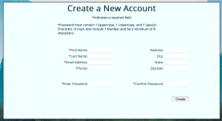
2 | Enter valid data in all required fields  Leave email and password blank  Full Name: Joe Smith  Email:  Password:  Confirm pass: | Input all valid data | Pass | Pass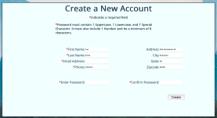
3 | Click Register | The system displays error messages like “Email is required” and: Password is required”  Registration does not proceed. | Pass | Pass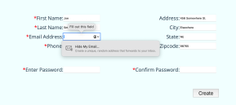
Comments | Comments should be substantive; this means there should be at least 2-3 well-structured sentences with constructive feedback.

